## Remote Workshop Cheat Sheet

Adapted from Miro.com by Nichole Carelock

## 

## 1. Before the Workshop

### Define Participant Roles and Agenda

There are two roles that work together in the running of a remote UX workshop: the *workshop leader* and the *assistant*:

**The workshop leader and facilitator** This is the person (most likely you) who, among other things, will “run the show,” manage workshop collaboration and timing, set the pace for the activities, and keep participants engaged.

**The assistant** It’s a good idea to delegate some tasks to others. This will help avoid bottlenecks and any unpleasant surprises during the workshop—like having to collect notes and explain the next steps simultaneously.

### Test the Tech in Advance

Despite the fact that a remote UX workshop’s ultimate performance greatly depends on the tech and the room, many of us still take for granted that it will all work out. This assumption can be dangerous. While it’s probably not possible to run a perfect UX workshop, with a bit of planning and enough testing, you can avoid most of the negative surprises.

### Define Agenda

Plan ahead with your assistant and decide which workshop techniques and tools you will use for the results you want to achieve.

1. Top three things you would like your participants to know
2. It's important to calculate the time for each task accurately—don't be too optimistic when estimating activity durations.
3. Schedule breaks so that participants can refocus their energies.

## 2. During the Workshop “In-the-roominess”

### Balance digital tools with sensorial experiences

One of the most difficult challenges when running a remote UX workshop is to find an ideal mix of digital tools and physical experiences that keep participants engaged. The goal is to keep the workshop flowing and participatory, while efficiently processing the content it generates.

1. **Create intimacy:** One formula that I use for any ideation or generative activity where we are creating ideas or concepts is to sketch alone for five minutes, then break into groups using breakout rooms in Zoom, then come back to the whole group to share in a circle. With this formula, people have figured out what to say so you can listen to others. The Pair and share model builds confidence in your solutions as well.
2. **Create a shared sensory environment.** Music can be an important part of workshops. When you are in a room physically with the people during a workshop, you can see people doing and working on the same thing. At home by yourself during a remote workshop, there’s no shared physical experience during heads-down work or ideation. It’s just silence. Music creates a cohesive virtual place that everyone is in as they sketch or brainstorm. It’s a shared sensory experience that keeps people engaged, productive and united.
3. **Wiggle Room**. When we are physically together we are triggered to take physical breaks. It’s important to build time into your agenda to stretch, take a break, and acknowledge that our bodies have been sitting in front of a screen.
4. **Embrace digital embodiment** Tele-presence tools like Zoom polling, hand raising and Sticky note boards can bring a kind of physicality to interactions.
5. **Curate a focused environment:** the less content onscreen at one time, the better. Be explicit about where you want their focus. *“Let’s look at our mural boards or now let’s focus on Zoom”*  The human brain can only take so much!
6. **Approximate movement** and transitions by physically engaging with the learning space. For a 'wallow', for example, maybe 'tour' the insights together in Mural; have stations set up where people can learn/do activities; listen to clips/voiceovers that encapsulate insights; gameification, in which people have to build a game together, or play a game on a gameboard researcher has created, to either absorb insights, or to start building user journeys together, etc.etc.

### Tools of the Trade

A good use of the fully remote format is when the team creates affinity diagrams, empathy maps, or user journeys using virtual boards. There is a lot of data on Collaboration tools and methods Below. They do an excellent job of breaking down what tool you should use for what type of activity. <https://www.nngroup.com/articles/tools-remote-ux-workshops/>

### Dealing with Tech Shyness and access issues

1. Workshop techniques that require drawing (like sketching) and other free-hand tasks (post-its) may make people feel like they have to be artistic to participate. Create vulnerability by sharing your own sketches.
2. People may feel overwhelmed by new technologies. Make sure you take time to explain the functionalities of the system
3. Some people on the team will not have access to the digital tools selected (software, proper hardware, etc.). Some online virtual boards limit the number of free users and adding the required number of participants is not feasible due to budget constraints

So instead of Post-its on a virtual board, you can use a shared online spreadsheet where each participant types their ideas into the spreadsheet’s cells (see below).

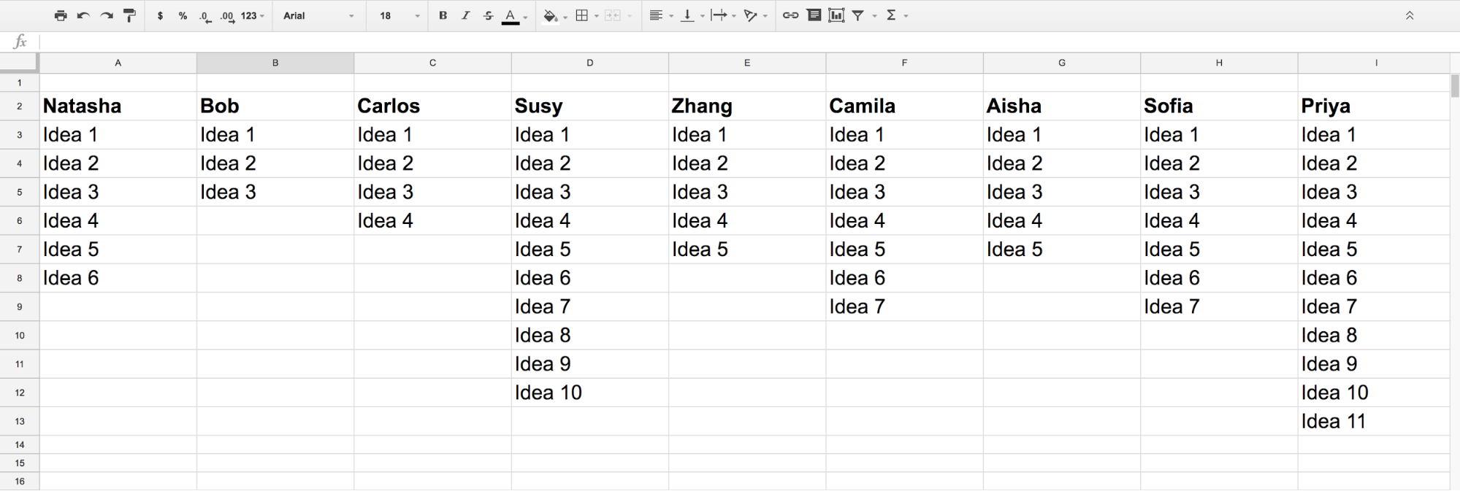

## 3. After the Workshop

### Get feedback, evaluate and improve

It’s a good idea to get feedback from your team after the workshop and identify areas that could be improved. The best time to do this is right after it is over because everything will still be fresh. For instance, as a result of the extensive use of technology in the case of a mostly digital approach, many pitfalls and potential glitches invariably surface—discussing why they occurred and how to circumvent it happening again is of great benefit to any team.

### Take care of your digital artifacts

The assets generated during the workshop are useful not only while it is in progress but can be used for further discussion or as a starting point for other workshops.

1. **Create a centralized, organized repository for the workshop.** For instance, a shared master folder with subfolders for each technique that was used during the workshop. Make sure to include links to virtual boards and any other external source/tool.
2. **Make sure that core artifacts are complete (sketches, spreadsheets, virtual boards, etc.).** When it isn't possible to finish them during the workshop, if you think they can be useful in the future, do it as soon as possible once it is over. Don't rely on your memory—months later, an unfinished sketch or spreadsheet may not make any sense to you.